

ADDENDUM n° -0584 to Installation, Operation and Maintenance Manual (IOM) n° -0256 LXST – LXXE
This addendum modifies information provided in the IOM No. -0256 for machines equipped with the option or QM 231 “ power factor correction”. It modifies following parts:
LXST – LXXE  IOM -0256 | Modifications
§4 Physical and electrical data for LXST-LXXE units  Electrical data notes and operating conditions for LXST-LXXE units | Modification of the maximum allowable THDV
§ 12 Major system components and operation data  §12.11 Power factor correction capacitors (option 231) | Addition.
§ 14 Standard maintenance  §14.2 Level 2 maintenance | Replacement
§ 14 Standard maintenance  §14.10 Check of power factor correction capacitors | Replacement

§LX
4 | Physical and electrical data for LXST/LXXE units
Electrical data notes and operating conditions for LXST/LXXE units

- The maximum Total Voltage Harmonic Distortion (THDV) for units with option / QM 231: 3%.
12  12.11 | Major system components and operation data  Power factor correction capacitors (option 231)
The following caution shall be added:
Caution:
- Operation of the unit without capacitors results in unit absorbed current raising. This is likely to happen if the internal thermostat is active if the ambient temperature is too high or if the cooling system is defective.
- The safe operation of the capacitors requires that they are checked periodically : refer to the document dedicated for this purpose
14  14.2  14.10 | Standard maintenance  Level 2 maintenance  The item for check of the operation of the capacitors shall be replaced by  - Units with option/QM231: proceed with the check list for the verification of the capacitors.  Check of power factor capacitors  This part shall be replaced by:  The commissioning and periodical verification of the capacitor is mandatory to insure safe operation. It includes the verification of the current, voltage, and capacitance and voltage distortion.  The procedure for these checks is described in a document that is dedicated for this purpose.

Appendix

Initial and periodical checks for capacitors used for power factor correction
Vérifications initiales et périodiques des condensateurs utilisés pour la correction de facteur de puissance
The verifications must be done initially, at start-up of the equipment as well as periodically every year
The results must be stored and made available for verification of the evolution in time.
The non application of the checks listed in this document can result in hazardous behavior of the capacitors
Safety rules
Always apply all standards safety rules for electrical intervention.
In addition, make sure that you understand below additional cautions :
Capacitors are energy storage devices: even after being switched off, they will remain energized. This can last indefinitely if the discharge circuit fails. Always apply following procedure when servicing the capacitor:
1- After switch off, wait five (5) minutes before any access to the connections of the capacitors or any live part that is connected to the capacitor. This shall allow the capacitor to discharge through the discharge circuit.
2- Prior to access to the connections, always check the absence of voltage.
3- Never perform any measurement on any connection if voltage is present
Tools for measurements
THDu: Power analyzer or other device with capability for THDu measurement
Capacitance: Multimeter or capacitance meter with accuracy better than 2%
Current: Power analyzer or multimeter with current probe
Voltage: Multimeter

Unit S/N:
Capacitor bench Description:  Select applicable designation |  | C1 |  | C2 |  | C3 |  |  | C1A | C2A | Power : | kVAr
Date | µF (1) |  |  |  |  |  | % (2) |  | % (3) | V (4) | A (5) | OK/NOK  (6)
YY MM/DD | 1-3 |  | 1-5 |  | 3-5 |  | Max unbalance |  | Max THDu | Max voltage | Max current | OK/NOK  (6)

Capacitor bench Description:  Select applicable designation |  | C1 |  | C2 |  | C3 |  |  | C1A | C2A | Power : | kVAr
Date | µF (1) |  |  |  |  |  | % (2) |  | % (3) | V (4) | A (5) | OK/NOK  (6)
YY MM/DD | 1-3 |  | 1-5 |  | 3-5 |  | Max unbalance |  | Max THDu | Max voltage | Max current | OK/NOK  (6)

Capacitor bench Description:  Select applicable designation |  | C1 |  | C2 |  | C3 |  |  | C1A | C2A | Power : | kVAr
Date | µF (1) |  |  |  |  |  | % (2) |  | % (3) | V (4) | A (5) | OK/NOK  (6)
YY MM/DD | 1-3 |  | 1-5 |  | 3-5 |  | Max unbalance |  | Max THDu | Max voltage | Max current | OK/NOK  (6)

(1) |  | For this measurement, the capacitors must not be electrically supplied: Fuse holders must be open.
 |  | Check the absence of voltage on the capacitor before performing the measurement.
 |  | The measurements can be done on the downstream power connections of the power contactors.
 |  | If several capacitors are connected to the same contactor, they must be disconnected.
The accuracy of the measurement device shall be better than 2% for the expected capacitance value (see table below)
The measured values must not be lower than the one stated in below column Alert -5% of the below table:
p/n capacitors |  | Capacitor power | Rated capacitance | Alert (-5%) | Rated current (In) | Alert (x1.3)
V(H)1040CB |  | 10 Kvar | 99 µF | 94 µF | 14 A | 18 A
V(H)1540CB |  | 15 Kvar | 150 µF | 142 µF | 22 A | 29 A
V(H)2040CB |  | 20 Kvar | 199 µF | 189 µF | 29 A | 38 A
V(H)2540CB |  | 25 Kvar | 247 µF | 234 µF | 36 A | 47 A
V(H)3540CB |  | 35 Kvar | 346 µF | 329 µF | 51 A | 66 A
V(H)4040CB |  | 40 Kvar | 398 µF | 378 µF | 58 A | 75 A
V(H)4540CB |  | 45 Kvar | 447 µF | 424 µF | 65 A | 85 A
 |  |  |  | Limits :
(2) | Max unbalance between the capacitances |  |  | <5% | Phase µF
  Average 3 phases µF
(3) | Voltage harmonic distorsion rate
 | P/N / Ref |  | V--40CB | <3%
(4) | Voltage (RMS value)
 | Max 1-2 / 2-3 / 3-1 |  |  | <440V
(5) | Maximum input current (between the 3 phases) |  |  | <1.3x In | See above table
(6) | Is one of the check not compatible with the stated limits?
Failure of the component in the end of life
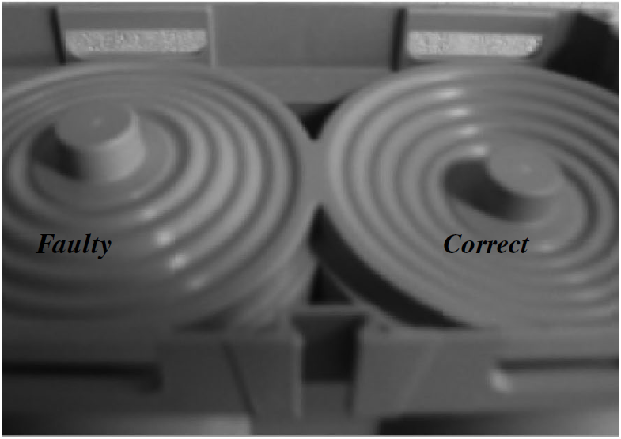
This can occur when the checks listed above did not allow to detect the capacitor end of life.
The capacitors are equipped with an internal overpressure system that disconnects the component at the end of its life. In case a failure is suspected, if the current value is below 0.8x the rated current, the operation of this protection shall be checked by removing the capacitors and checking the underside:

